**Objectives**

* Demonstrate creation of navigation bar items
  + navbar-nav, nav-item, nav-link
* Demonstrate collapsing navigation items
  + navbar-toggler, navbar-toggler-icon, collapse, navbar-collapse, ml-auto
* Demonstrate troubleshooting UI issues using Chrome Developer Tools
  + Element selection
    1. using Inspect
    2. selection tool in Developer Console
    3. Hovering over the elements in the HTML code within the "Element" section of Developer Tool
  + Applying Styles directly using Developer Tools
    1. Add new style in the style window
    2. Disable an existing style using the checkbox
    3. Change value of an existing style
* Demonstrate using badge component
  + badge, badge-primary
* Demonstrate using third party icons in web page design
  + Google Material Icon, Content Delivery Network (CDN), include icons in web page
* Demonstrate displaying a list of items
  + list-group, list-group-item

**Navigation Bar Items for hTrack**

Include navigation bar items in the navigation bar created for hTrack login page. Refer screen shots below:

**Desktop**

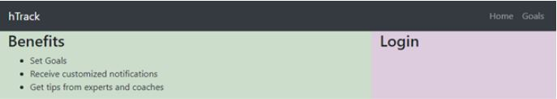

**Mobile**

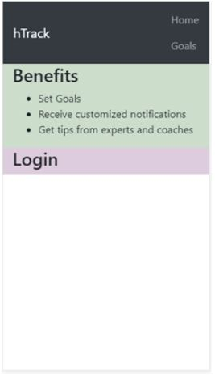

**Hamburger menu for mobile devices**   
  
The navigation menu items displayed in two lines. Consider a situation where there are more navigation items, which will make the display of navigation items clumsy. In mobile devices, the navigation items should collapse within a hamburger menu. Clicking on the hamburger menu should display the menu items. Change the previous HTML page completed to display hamburger menu in mobile devices. Refer screen shots below with collapsed and expanded view of navigation items. 

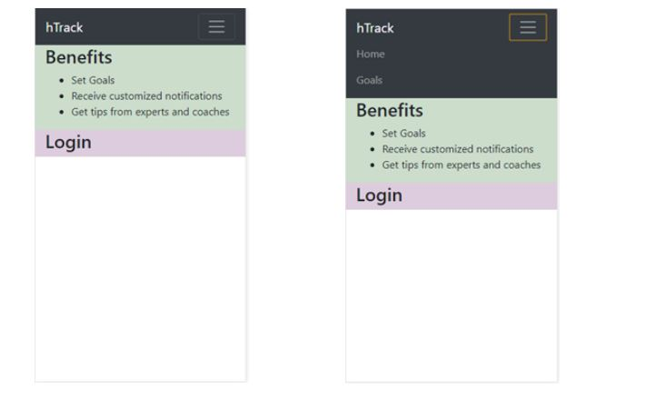

**Changing styles directly in browser using Chrome Developer Tools**

Change the style of "Benefit" heading in hTrack application using Chrome Developer Tools using the steps specified below:

* Open the hTrack login screen in the browser
* Open Chrome Developer Tools
* Select the heading “Benefits” using Chrome Developer Tools
* In developer tools, increase 20px padding on top of the heading “Benefits”
* Uncheck “font-weight” style to disable and observe the changes in "Benefits" heading
* Change the color of “Benefit” heading to blue color

**Create a badge for displaying rating**

There is a need to display the rating of a product similar to the layout given below. Create a similar layout using Badges option in Bootstrap.

https://cognizant.e-box.co.in/uploads/Image/BTS8.JPG

**Create icons for navigation item**

Include home icon adjacent to “Home” navigation item using Google Material Icon.

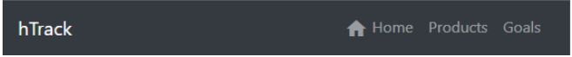

**Steps to use Google Material Icon**

1. Include CSS link in header

<link href="https://fonts.googleapis.com/icon?family=Material+Icons" rel="stylesheet">

1. In the web page where the icon needs to be included, specify the below code:

<i class="material-icons">face</i>

1. To display the icon of your choice, find icon name from the link below and change “face” with the respective icon name.

https://material.io/tools/icons/?style=baseline

1. To align the icon, use any one of the below option:
   1. Include the following style in CSS:
   2. .material-icons {
   3. vertical-align: middle;

}

* 1. To increase / decrease the icon size create a new class in CSS with font size and include it in the material icon definition

<i class="material-icons" class="icon-size">face</i>

**Listing Items**

Display list of events similar to the layout specified below using List Group component in Bootstrap.  
